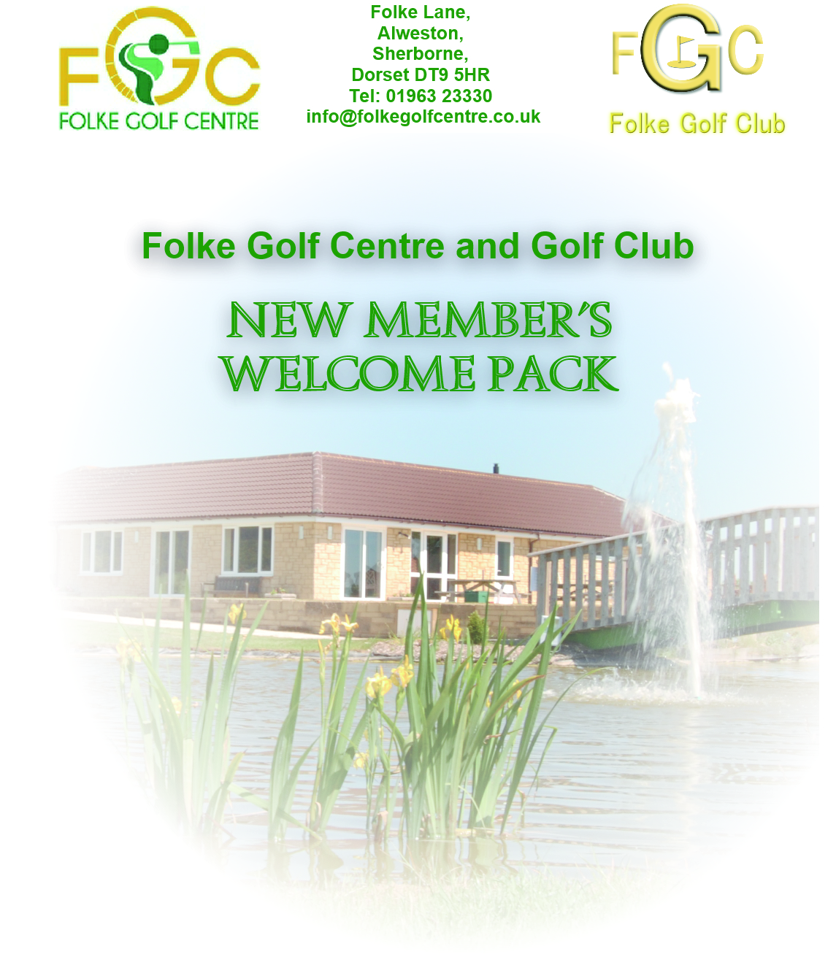

This Welcome Pack has been produced as a guide for prospective members of Folke Golf Centre and Folke Golf Club and contains all the information required to become an active participant in the Folke golfing world – where golf is supposed to be fun!.

CONTENTS

Section 1 – Welcome and General Introduction

Section 2 – Overview of Membership Options
2.1 Social Golf
2.2 Competitive Club Golf

Section 3 – Folke Golf Centre Information
3.1 Centre Fees and Membership Details
3.2 Folke Golf Centre General Information

Section 4 – Folke Golf Club Information
  - Golf Club Fees and General Information
  - How to Get Your Handicap
  - Folke Golf Club General Information
  - Club Organisation

Section 5 – Membership Application Forms
5.1 Centre Membership Application Form
5.2 Club Membership Application Form

Section 1 – Welcome and Introduction

On behalf of Folke Golf Centre and Folke Golf Club we would like to offer you a warm welcome and hope that your golfing experience here will surpass all your expectations. This Welcome Pack explains all the options available for membership of the Centre and the Club and what you have to do to get the membership option that you choose.

It also provides information about the facilities available, the contact points for further information, and identifies the staff and club officials that are involved in the day to day activities.

Section 2 of the Welcome Pack gives an overview of the membership options and the procedure to become a Centre and Club member.

Sections 3 and 4 provide more details about the Centre and the Club respectively and Section 5 contains the Application Forms you will need to complete and submit to become a member.

Section 6 contains some additional reference material to get you up to speed with events at Folke.

All the contacts you will need are shown in the following Sections but in the event of any problems or need for further information please contact;
- Centre Manager Steve Harris
Tel. 01963 23330
email:info@folkegolfcentre.co.uk or

Section 2 – Overview of Membership Options

To determine the membership package that is right for you the first thing you will need to decide is:
Do you want to just play social golf with friends and other centre members or do you want to get a handicap (or maintain an existing handicap) and get involved in competitive club competitions and team events?
2.1 Social Golf
For social golf, all you need is the annual or multi-year Centre Membership that covers 7 days a week green fees. The details are shown in Section 3.

2.2 Competitive Club Golf
For competitive golf, you will need to take up Folke Golf Club membership and:-
Either sign up for the annual Centre Membership to cover your green fees, or pay the Centre ‘Pay and Play’ green fees whenever you play in a club event.

When you join the club, if you have not got an official handicap you will get 54 holes of golf for your handicap assessment.

The Club Membership prices and membership details are shown in Section 4.

Section 3 – Folke Golf Centre Information

3.1 Centre Fees and Membership Details

- For the detailed pricing for adult or junior Centre membership please contact Steve Harris at Folke Golf Centre (Tel: 01963 23330). The annual membership for the golf Centre is payable in a single payment or by a monthly direct debit. (Occasionally, a multi-year deal may be offered by the Centre Manager for long term members when the annual renewal is due).
- To apply for Centre Membership, fill in the Centre Application Form in Section 5.1, cut out the form and hand it (or post it) to Steve Harris at Folke Golf Centre.

3.2 Folke Golf Centre General Information

At Folke Golf Centre, we believe that golfing should be a relaxing, friendly, and enjoyable experience enjoyed by all ages and golfing abilities. We are a privately run business where the Centre Manager, staff and the Green keeper are mostly family members dedicated to providing a friendly service and continuously improving the course and facilities.

The nine hole course with alternate tees form a 18 hole, over 6000 yard, course with water features, trees, doglegs and tricky greens. It is set in the beautiful Dorset countryside away from the hustle and bustle and noise of everyday life. Thee standard scratch score is 71. Practise facilities include a Putting Green, and Sand Bunker.

The course provides a challenge for golfers of all abilities. With 3 par 5, 4 par 3, and 11 par 4 holes, every club in the bag will come into play at some stage in the round. The twelfth dog-leg hole with ‘Out Of Bounds’ on each side is a particularly tricky hole that requires accurate distance and direction with each shot. Excellent greens all year round, several water features and an abundance of wild life will make your visits very special. The course does not feature any steep gradients and is suitable for golfers over the full range of athletic abilities.

The Club House includes a Spike Bar, Four Seasons Restaurant, and Golf Shop. There is an extensive menu available in the bar and restaurant at very competitive prices and a regular Sunday carvery and special theme nights and events can be enjoyed by all. The modern changing room facilities include lockers and showers. For more information checkout our Web Site www.folkegolfcentre.co.uk and follow us on Facebook.
Section 4 – Folke Golf Club Information

  - Folke Golf Club Fees and Membership Details

- The annual subscription for new members of Folke Golf Club for 2023 is £100 plus £20 for applicants that do not have an official handicap. For juniors aged 16 and under, the membership price is £35. Annual club membership (and annual membership renewal) commences in January. (For information, the renewal price for existing members for 2023 is £70)
- Club Membership allows you to get a handicap (or maintain your existing one) and to take part in club competitions and play in league matches against local clubs. Members aged 55 or over can also take part in friendly senior matches against other senior local cubs.

- Club Membership also includes:
- Third party golf insurance.
- A County Card that provides discounted green fees at golf clubs throughout the South West and other English counties.
- English Golf Union (EGU) and Dorset County Golf Union (DCGU) affiliation fees.
- To apply for Club Membership, fill in the Club Member Application Form in Section 5.2, and hand it (or post it) to Steve Harris, or deposit it in the Club Letter Box adjacent to the Notice Board in the clubhouse.

  - How to Get Your Handicap
As an England Golf affiliated organisation, Folke Golf Club use the official World Handicap System whereby handicaps are monitored and maintained by the England Golf official software application. The World Handicap System was launched by EnglandGolf in 2020 and a computer station in the clubhouse is used to check your handicap, register for competitions and input your scores.

Folke Golf Club will arrange this on your behalf so all you have to do is submit a number of cards, completing 54 holes. The cards can be a mix of 9 and 18-hole rounds, but 3 x 18 holes is the preferred option. The cards must be marked and signed by the marker and the player. The Handicap Secretary will then allot you a handicap based on the submitted cards that will ultimately take into account the best 8 scores over the last 20 rounds.

Notes:
a) When you submit your club membership application form a club member may contact you to welcome you and to check if you need any help to arrange your qualifying rounds.
- The information that you provide to the club will only be used for club purposes in accordance with the General Data Protection Requirements (GDPR). The purposes will be defined and formal permission for such use of the information will be requested via a club GDPR form. (Please note that to obtain or maintain an official World Handicap System handicap, EnglandGolf require your email address and Date of Birth information)

4.3 Folke Golf Club General Information

Folke Golf Club is a friendly and successful golf club that competes in many of the local golf leagues and has an active schedule of competitions. Our club has about 100 members and the intra-club and external team competitions take place throughout the year. The intra-club competitions include Sunday and weekday medal competitions once a month for all club members and regular roll-ups on other weekends, plus day and weekends away, Summer and Winter knock-outs, and club and senior championship events.

The club takes part in four different league and friendly team events against other local clubs as shown below. Hardy A, Hardy B, and Three Counties matches all take place at weekends. Senior events invariably take place on weekdays. Team captains ensure that everyone who enters will get a chance to play in the team. Golfers with handicaps higher than those shown below are eligible to play in the teams but must play off the highest level of handicap shown.
- Hardy A
The Hardy A Team is singles match play for players with handicaps of 10 or less.

- Hardy B,
The Hardy B league matches are 5 x 4 balls for handicaps of 11 to 18.

- Three Counties League
The Three Counties league matches are 6 x 4 balls for handicaps of up to 28.

- The Senior Section
The seniors meet most Tuesday and Thursday mornings. The score cards are compiled on arrival and drawn randomly so that everyone gets to know, and play with, other members. There is also a comprehensive series of home and away friendly matches with many of the local clubs including Wincanton, Charminster, Sturminster Marshall, Parley Court, Cannington, Henstridge, Westbury, Fosse Way and Christchurch. These matches are open to all senior players (age 55 and over) and all levels of handicap and all seniors are encouraged to take part and experience the fun of meeting other clubs members and playing in the many different venues. Match fees are subsidised by the club.

Further information on all the teams and the club calendar of events can be seen on the Folke Golf Club section of the Folke Golf Centre web site (www.folkegolfcentre.co.uk) and Facebook page.

4.4 Club Organisation
The club is run by a committee of officials elected at an Annual General Meeting and there are monthly committee meetings to review club activities and any ongoing issues that need to be addressed. All club members are encouraged to take an active part in the meetings. The latest Admin information can be seen on the club Members Admin page of the web site.

For more information check out the Folke Golf Club web pages which are incorporated into Folke Golf Centre Web Site www.folkegolfcentre.co.uk and follow us on Facebook.
Section 5 - Membership Application Forms

5.1 Centre and Club Membership Application Forms

To apply for Centre and Club membership please fill in the appropriate form(s) below, and hand them into the Clubhouse or post to

Mr Steve Harris
Folke Golf Centre
Folke Lane
Alweston
Sherborne
Dorset DT9 5HR

5.1 Folke Golf Centre Membership Application Form

FOLKE GOLF CENTRE MEMBERSHIP APPLICATION FORM
Name |  |  | Junior o 15 – 55 o Over 55 o
Address |  |  | Post Code
Home Phone |  | Mobile | email
Membership  Option  Required (X) | Multi Year o 12 Months o 12 Months o  Single Payment Direct Debit |  | Required Start Date
Signature |  |  | Date

5.2 Folke Golf Club Membership Application Form

FOLKE GOLF CLUB MEMBERSHIP APPLICATION FORM
Name |  |  | Date of Birth
Address |  |  | Post Code
Home Phone | Mobile |  | email
Do you have a Current Handicap? YES/NO  If Yes:  CDH No.___________________  H/Cap ___________________  Prev Club___________________ |  | Are you applying for or have Centre Membership?  YES/NO | Required Start Date
Signature |  |  | Date
The Account details of Folke Golf Club are as follow:  A/C Name: Folke Golf Club  Soft Code: 60-19-12  A/C No.: 97864692 |  |  | New Member Subscriptions:  No Handicap: £120  With Handicap: £100  Pay via BACS or place cash in envelope and put in Club Mail Box in the club house.

